**ECS 204: SIGNALS AND SYSTEMS**

**PROGRAMMING ASSIGNMENT**

**NAME: Ishanya**

**ROLL NO: 21329**

**DATE: 20 April 2023**

**Question 3.**

**Code**

% Name: Ishanya

% Roll number: 21329

Q1 = 2/5;

Q2 = 1;

Q3 = 200;

omega_a = 10000;

% Bode plots for case (i)

sys1 = tf(omega_a^2, [1, omega_a/Q1, omega_a^2]);

figure;

bode(sys1);

title(['Bode Plot for Q = ', num2str(Q1)]);

% Bode plots for case (ii)

sys2 = tf(omega_a^2, [1, omega_a/Q2, omega_a^2]);

figure;

bode(sys2);

title(['Bode Plot for Q = ', num2str(Q2)]);

% Bode plots for case (iii)

sys3 = tf(omega_a^2, [1, omega_a/Q3, omega_a^2]);

figure;

bode(sys3);

title(['Bode Plot for Q = ', num2str(Q3)]);

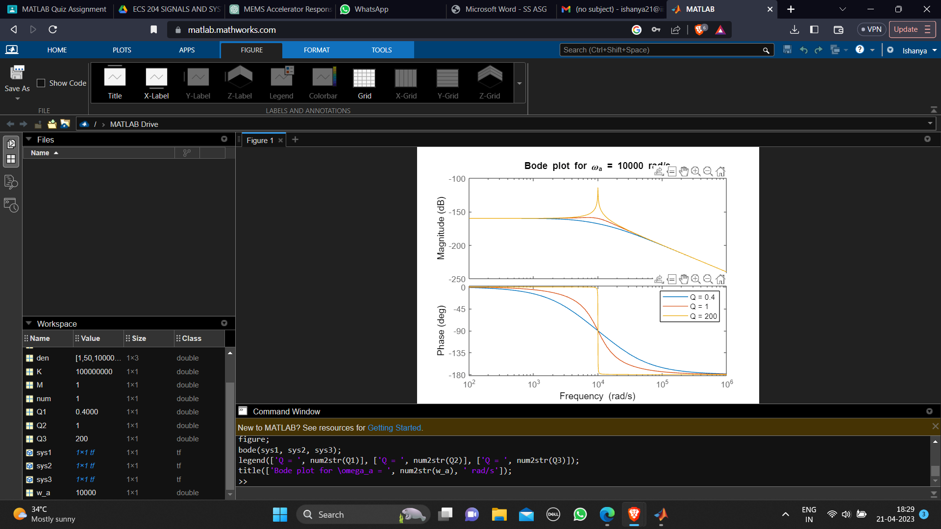

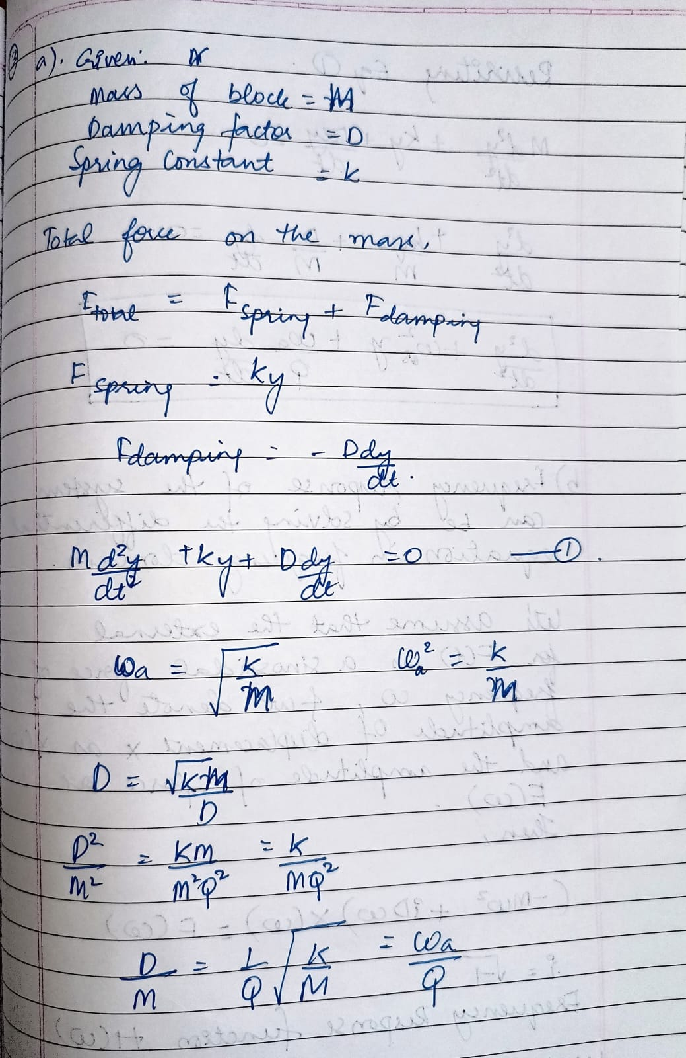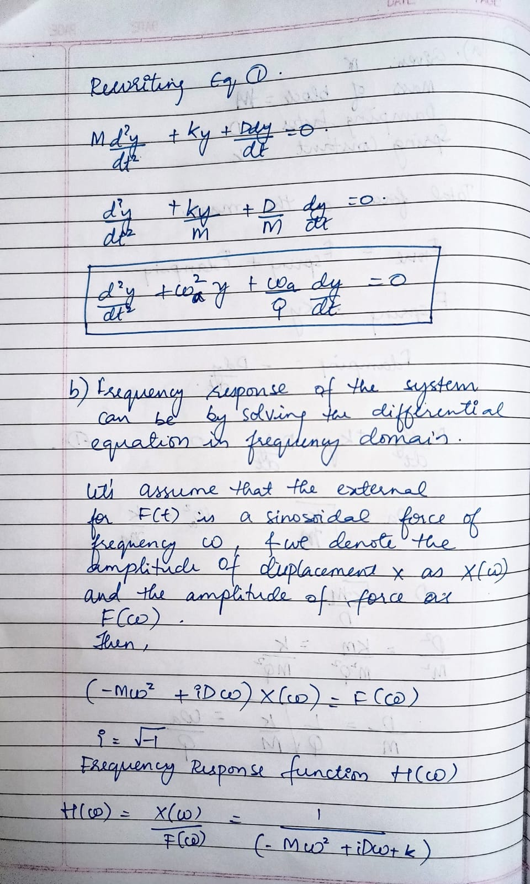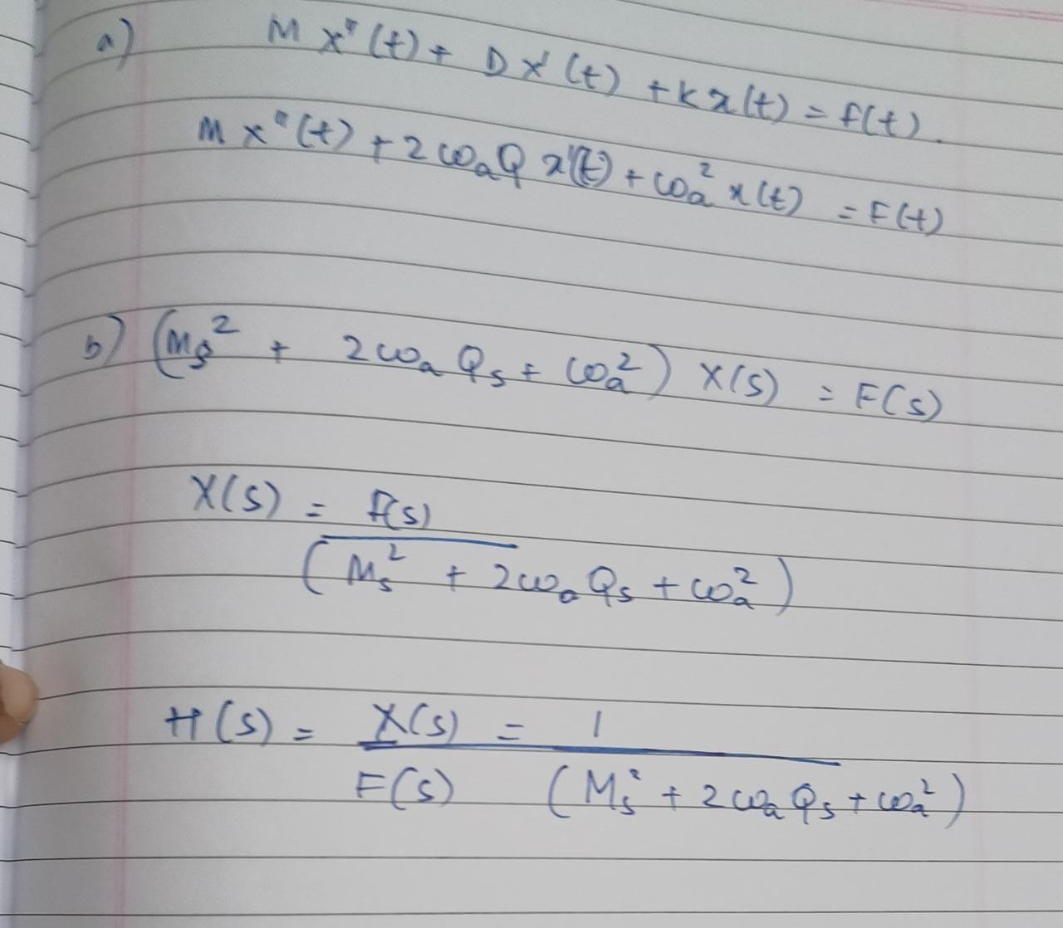

QUESTION.3)a.

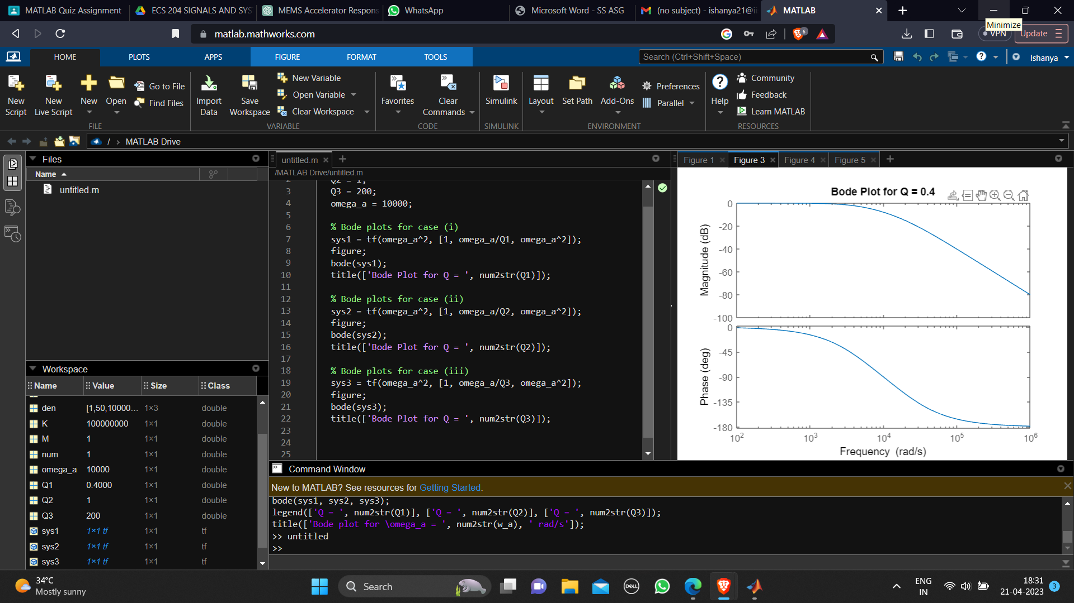

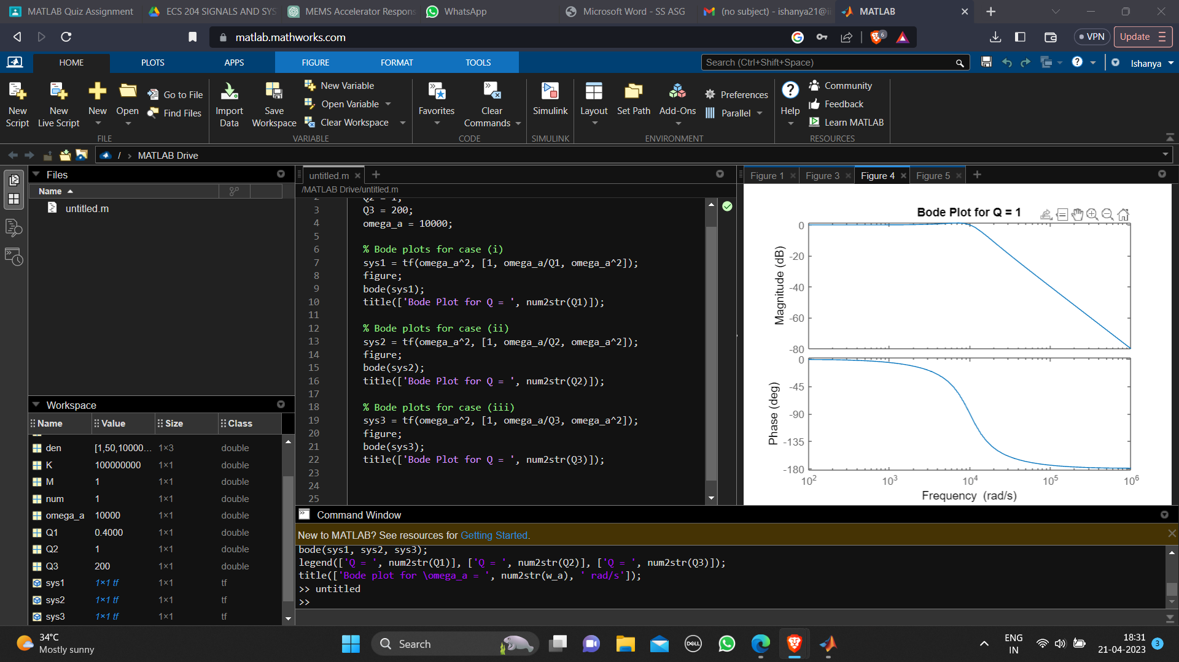

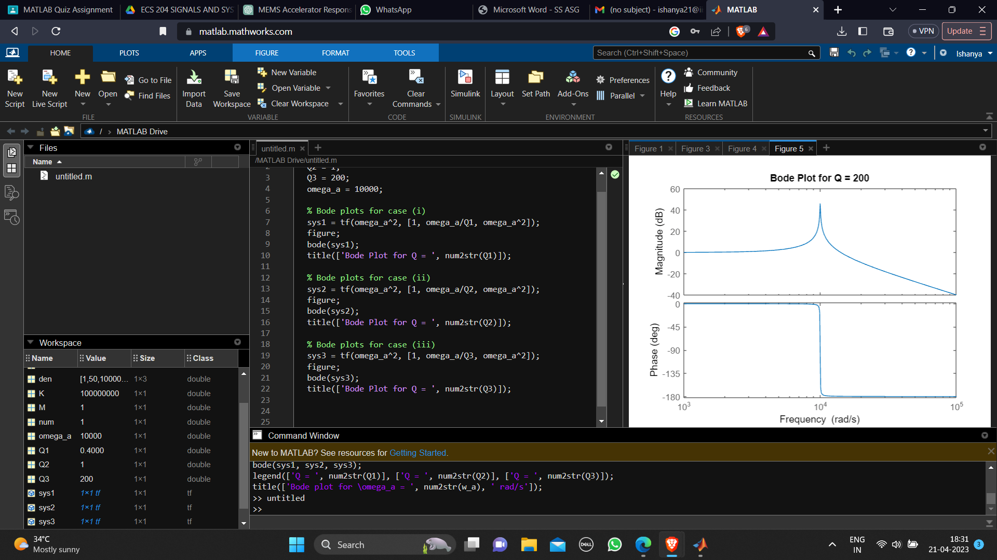

**Inference:**

A Bode plot is a graphical representation of the frequency response of a system. It consists of two plots: the magnitude plot (in dB) and the phase plot (in degrees). Let's plot the Bode plots for the given values of Q and ωa = 10,000 rad/s:

1. Q = 2/5: Plugging Q = 2/5 and ωa = 10,000 rad/s into the equation for the frequency response function H(ω), we get: H(ω) = 1 / (-Mω^2 + (iD/5)ω + K) From the above equation, we can see that the system has a resonance peak at the natural frequency ωa, and the peak is lower compared to the case with higher quality factor. The magnitude of the frequency response will be lower, and the phase will have a larger shiŌ at the resonance frequency.
2. (ii) Q = 1: Plugging Q = 1 and ωa = 10,000 rad/s into the equation for the frequency response function H(ω), we get: H(ω) = 1 / (-Mω^2 + iDω + K) From the above equation, we can see that the system has a resonance peak at the natural frequency ωa, and the peak is moderate compared to the cases with higher and lower quality factors. The magnitude of the frequency response will be moderate, and the phase will have a moderate shift at the resonance frequency.
3. (iii) Q = 200: Plugging Q = 200 and ωa = 10,000 rad/s into the equation for the frequency response function H(ω), we get: H(ω) = 1 / (-Mω^2 + (200iD)ω + K) From the above equation, we can see that the system has a resonance peak at the natural frequency ωa, and the peak is higher compared to the cases with lower quality factors. The magnitude of the frequency response will be higher, and the phase will have a smaller shift at the resonance frequency.

(i) For Q = 2/5, the system will have a lower magnitude response and a larger phase shift at the resonance frequency compared to the other cases. (ii) For Q = 1, the system will have a moderate magnitude response and a moderate phase shift at the resonance frequency.